**Here are some activities you can do with students to get to know each other a little better. All students are encouraged to participate. You can also choose 1 student to go first, and have that student choose who goes next.**

1. **Have You Ever?**

* Materials needed: NONE :)
* Students stand in a large circle. One volunteer stands in the middle.
* The volunteer asks a question that starts with “Have You Ever…?”
* If you have, you must exchange places with someone else in the circle. You cannot move directly to your right or left.
* The last person to find their spot is in the middle!

1. **Common Grounds**

* Materials needed: paper and pencil
* Divide students into groups of 3-5.
* Challenge students to come up with as many similarities as possible.
* **Time**: 3 minutes
* Follow up discussion questions (optional): How easy was it to discover something in common with another group member? • How can similarities draw us closer together? • How can our differences draw us closer together?

1. **Color Coded Questions**

* Materials needed: items of 4 different colors (i.e. candy, pencils, paper clips, paper)
* Students choose 1 object from a bag without looking at the color. Based on the color chosen, he/she will answer the following questions?
* Color 1 = What would you do if you had $1 million?
* Color 2 = If you were stranded on a desert island, what three items would you want to have with you?
* Color 3 = If you could have an endless supply of any food, what would you get?
* Color 4 = If you could invite five famous or noted people (past or present) to dinner who would you choose?

1. **Human Bingo / Human Scavenger Hunt**

* Materials needed: Bingo/Scavenger Hunt Sheets (enough for each student), pencil/pen
* Students will move around the room, finding DIFFERENT people to sign each box, if he/she meets the criteria in the box.
* Each person can only write his/her name twice!
* **Time**: 15 minutes

1. **4 Directions**

* Materials needed: 4 pieces of paper labeled N, S, E, W; place on 4 walls
* Instructor will read a list of statements.
* Students will move around the room (North, South, East, West), based on their answer.
* *See attachment*

1. **Stand Up – Sit Down**

* Materials needed: List of statements
* All students will begin by standing up.
* Instructor will read a statement from the list, one at a time.
* Students will stand if their answer is *YES*. Students will sit if their answer is *NO*.
* After each statement, allow 1-3 students to share or elaborate on their answer.
* I am happy the school year is over.
* I am an only child.
* I have one or more brothers.
* I have one or more sisters.
* I like to read.
* I like to draw.
* I like to play sports.
* I speak more than 1 language.
* I play a musical instrument.
* I have broken a bone.
* I have met someone famous.
* I have traveled outside of the state.
* I have traveled outside of the country.
* I am looking forward to my summer break!

1. **Blobs And Lines**

* Materials needed: NONE :)
* Students are prompted to either line up in some particular order (by birthday, for example) or gather in “blobs” based on something they have in common (similar shoes, for example).
* Here are some sample prompts you can use for this game:
  + Line up in alphabetical order by your first names.
  + Line up in alphabetical order by your last names.
  + Line up in order of your birthdays, from January 1 through December 31.
  + Gather with people who have the same eye color as you.
  + Gather with people who get to school in the same way as you (car, bus, walk).
  + Gather into 3 blobs: Those who have LOTS of chores at home, those who have A FEW chores at home, and those who have NO chores at home.
  + Gather with people who have the same favorite season as you.

**H U M A N**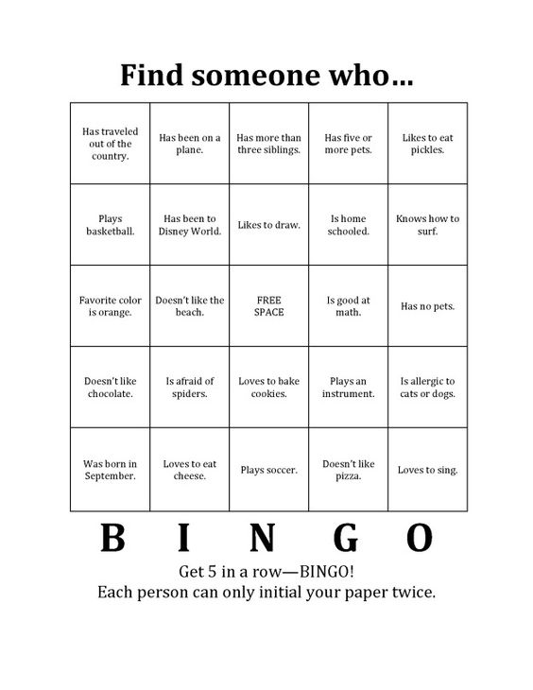 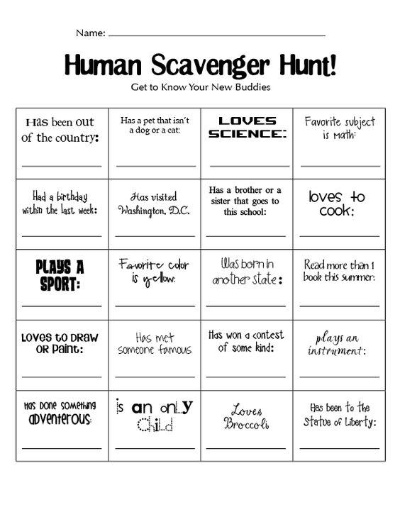

**4 Directions**

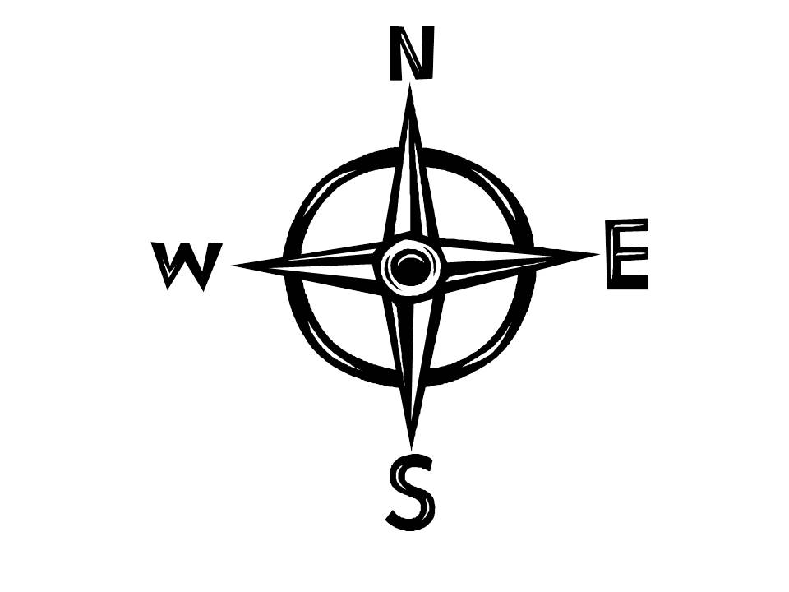

|  |  |  |  |  |
| --- | --- | --- | --- | --- |
|  | **North** | **East** | **South** | **West** |
| Would you rather use your… | Cell phone | TV | Video Game Console | iPod |
| Do you prefer… | Summer | Winter | Spring | Fall |
| Would you rather visit… | California | Hawaii | Alaska | Colorado |
| Which subject do you prefer… | Math | Science | Language Arts | History |
| Which continent would you rather to visit… | Asia | Australia | Africa | Europe |
| Would you rather eat… | Waffles | Pancake | Eggs | Bacon |
| Would you rather eat… | Pizza | Burger | Hot dog | Salad |
|  |  |  |  |  |

